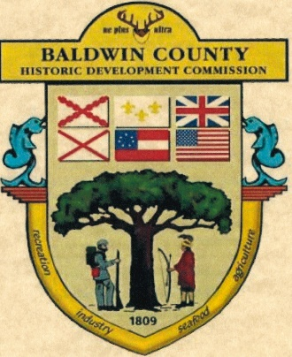
Application for a replacement for an existing
Baldwin County Historic Development Commission Banner & Shield.

In the event the property owner would like a new banner with a name change, the applicant may submit the request in letter format including the address of the property, a photograph of the home and the current Banner, and a check for $50.00.
In the event of damaged or aged plaques, replacement Banners and Shields may be requested in writing for a cost of $150
Please mail completed application to Baldwin County Historic Development Commission C/O: Archives and History 312 Courthouse Square, Suite 26, Bay Minette, AL 36507 with check made payable to the Baldwin County Historic Development Commission (or BCHDC).
Property Owner’s Name ______________________________________________________________________

Property Owner’s Mailing Address ____________________________________________________________________________________________

Phone # Cell # Email address ____________________________________________________________________________________________

Street Address of Property ____________________________________________________________________________________________

Name on Banner as it currently appears ____________________________________________________________________________________________

